LAB EXPERIMENTS
ECA1408-EMBEDDED SYSTEMS

Exp-24:
Code:
#include <systemc.h>

SC_MODULE(Design) {
sc_in<bool> clk;

SC_CTOR(Design) {
SC_THREAD(task1);
SC_THREAD(task2);
}

void task1() {
for (int i = 1; i <= 3; i++) {
wait(clk.posedge_event());
cout << sc_time_stamp()
<< " Task 1: " << i << endl;
}
}

void task2() {
for (int i = 1; i <= 3; i++) {
wait(clk.posedge_event());
cout << sc_time_stamp()
<< " Task 2: " << i << endl;
}
}
};

int sc_main(int argc, char* argv[]) {
sc_clock clk("clk", 10, SC_NS);
Design d("d");
d.clk(clk);
sc_start(40, SC_NS);
return 0;
}
Result:
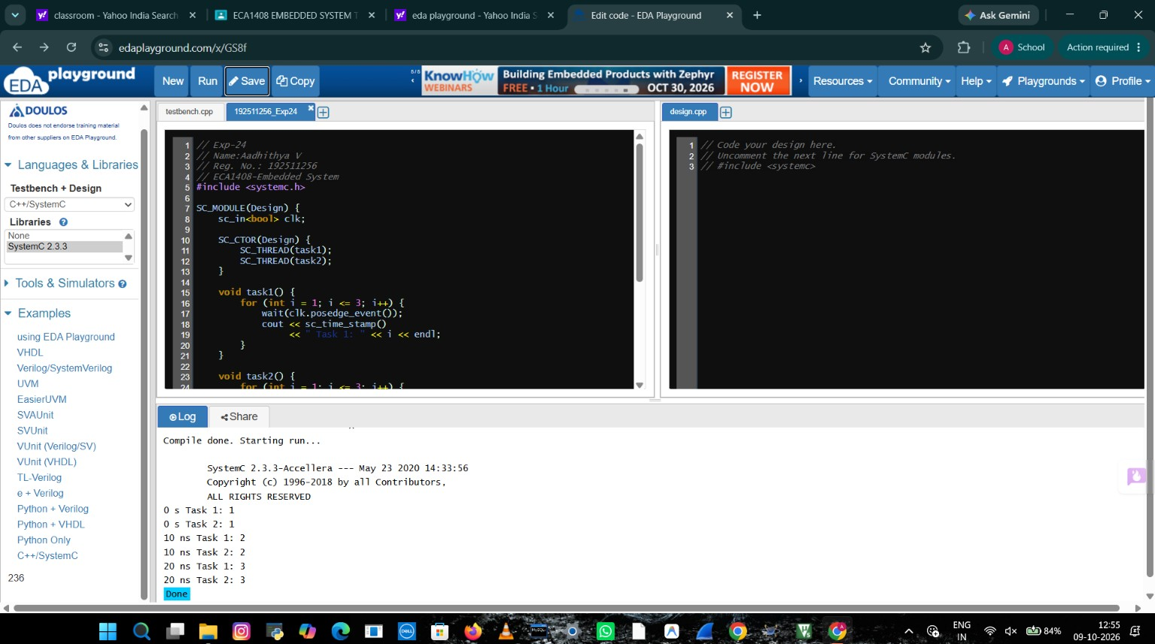

Exp-25:
Code:
#include <systemc.h>

struct Transaction {
int address;
int data;
};

SC_MODULE(Receiver) {
void receive(Transaction t) {
cout << "Address: " << t.address << endl;
cout << "Data: " << t.data << endl;
}

SC_CTOR(Receiver) {}
};

SC_MODULE(Sender) {
Receiver* receiver;

SC_CTOR(Sender) {
SC_THREAD(send);
}

void send() {
Transaction t;
t.address = 100;
t.data = 250;

wait(5, SC_NS);
cout << "Sending transaction" << endl;
receiver->receive(t);
}
};

int sc_main(int argc, char* argv[]) {
Receiver r("receiver");
Sender s("sender");
s.receiver = &r;

sc_start(10, SC_NS);
return 0;
}

Result:
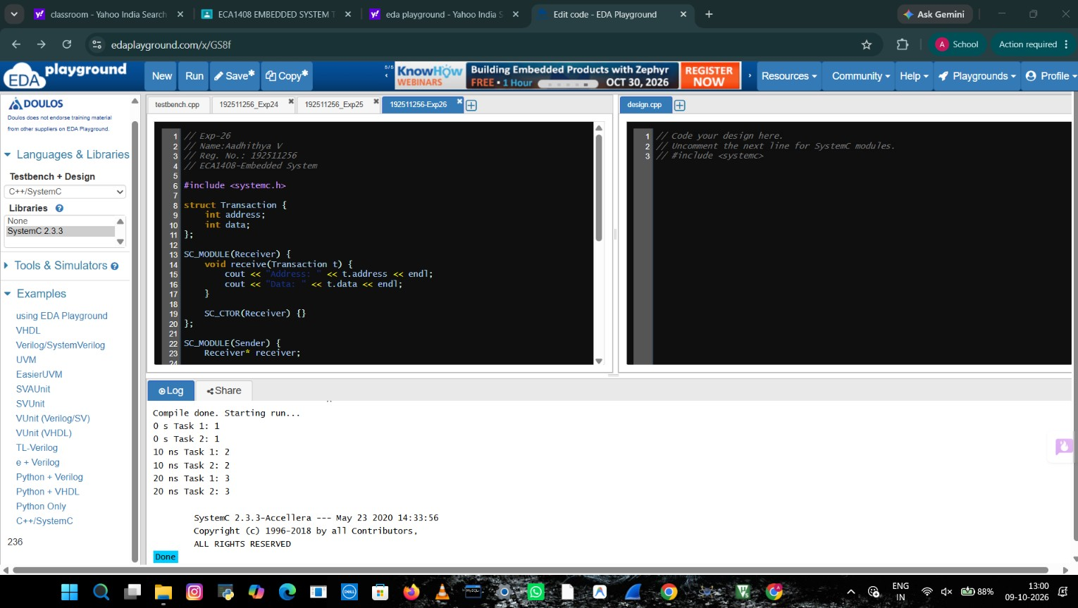
Exp-26:
Code:
#include <systemc.h>

SC_MODULE(ProducerConsumer) {
sc_fifo<int> fifo;

SC_CTOR(ProducerConsumer) : fifo("fifo", 2) {
SC_THREAD(producer);
SC_THREAD(consumer);
}

void producer() {
for (int i = 1; i <= 5; i++) {
fifo.write(i);
cout << "Produced: " << i << endl;
wait(2, SC_NS);
}
}

void consumer() {
for (int i = 1; i <= 5; i++) {
int data = fifo.read();
cout << "Consumed: " << data << endl;
wait(3, SC_NS);
}
}
};

int sc_main(int argc, char* argv[]) {
ProducerConsumer pc("pc");
sc_start(30, SC_NS);
return 0;
}

Result:
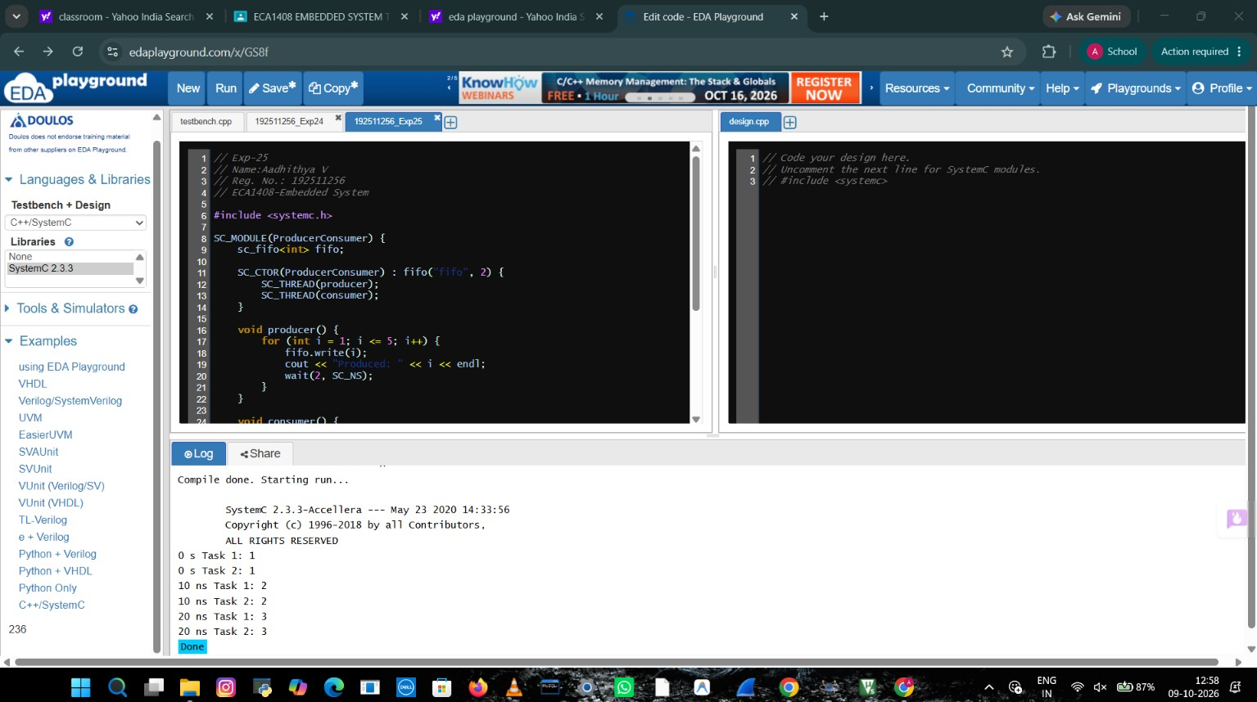

Exp-27:
Code:

#include <systemc.h>

SC_MODULE(SemaphoreDemo) {
sc_semaphore sem;

SC_CTOR(SemaphoreDemo) : sem("sem", 1) {
SC_THREAD(task1);
SC_THREAD(task2);
}

void task1() {
sem.wait();
cout << "Task 1 acquired resource" << endl;
wait(5, SC_NS);
cout << "Task 1 released resource" << endl;
sem.post();
}

void task2() {
wait(1, SC_NS);
sem.wait();
cout << "Task 2 acquired resource" << endl;
wait(2, SC_NS);
cout << "Task 2 released resource" << endl;
sem.post();
}
};

int sc_main(int argc, char* argv[]) {
SemaphoreDemo d("d");
sc_start(15, SC_NS);
return 0;
}
Result:
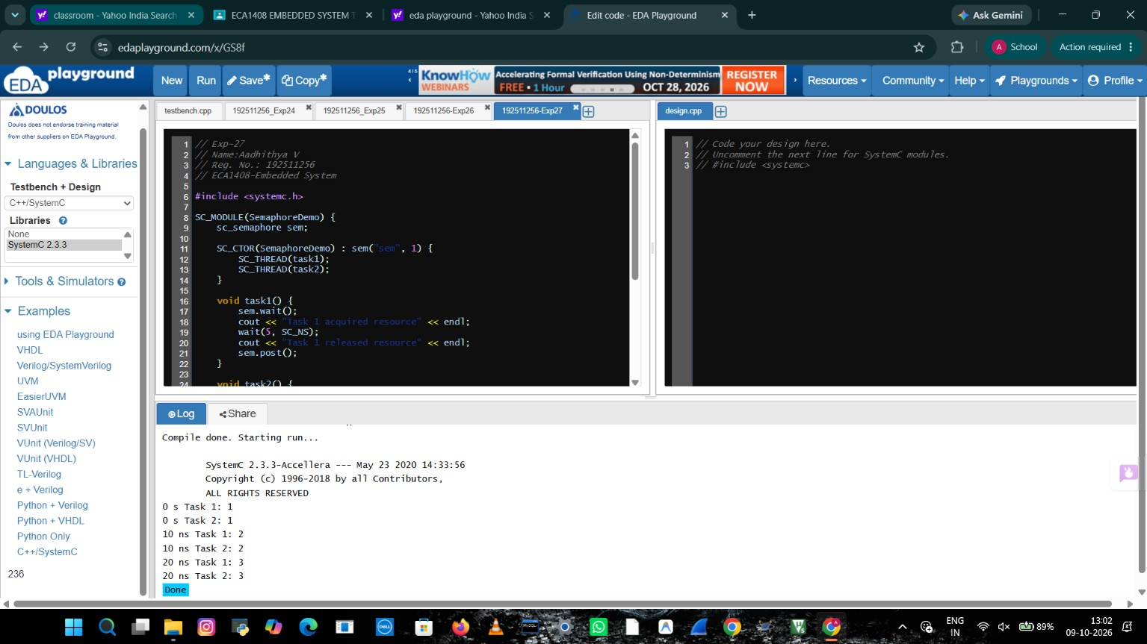

Exp-28:
Code:

#include <systemc.h>

SC_MODULE(CountingDemo) {
sc_semaphore sem;

SC_CTOR(CountingDemo) : sem("sem", 2) {
SC_THREAD(task1);
SC_THREAD(task2);
SC_THREAD(task3);
}

void task(int id) {
sem.wait();
cout << "Task " << id << " acquired resource" << endl;
wait(4, SC_NS);
cout << "Task " << id << " released resource" << endl;
sem.post();
}

void task1() { task(1); }
void task2() { task(2); }
void task3() { task(3); }
};

int sc_main(int argc, char* argv[]) {
CountingDemo d("d");
sc_start(15, SC_NS);
return 0;
}
Result:
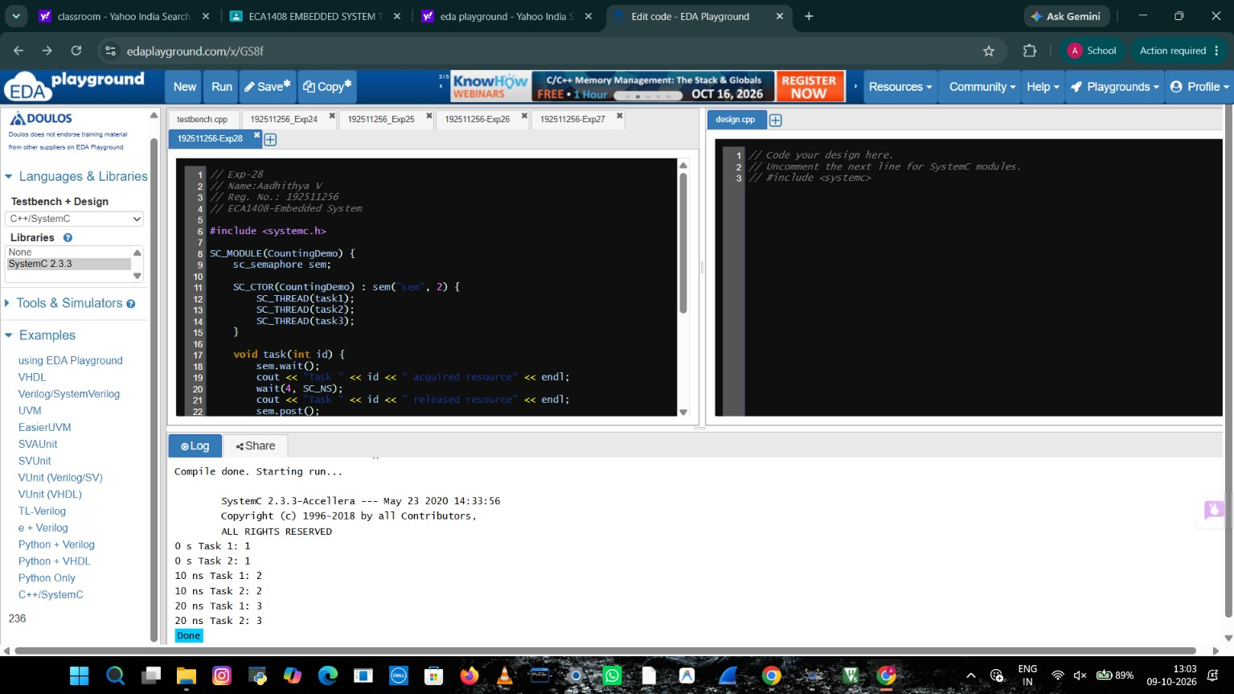
Exp-29:
Code:

#include <systemc.h>

SC_MODULE(InterruptDemo) {
bool high_pending, low_pending;

SC_CTOR(InterruptDemo) {
high_pending = false;
low_pending = false;
SC_THREAD(run);
}

void run() {
wait(5, SC_NS);

low_pending = true;
high_pending = true;

cout << "Interrupts received" << endl;

if (high_pending) {
cout << "High-priority interrupt serviced" << endl;
high_pending = false;
}

if (low_pending) {
cout << "Low-priority interrupt serviced" << endl;
low_pending = false;
}
}
};

int sc_main(int argc, char* argv[]) {
InterruptDemo d("d");
sc_start(10, SC_NS);
return 0;
}
Result:
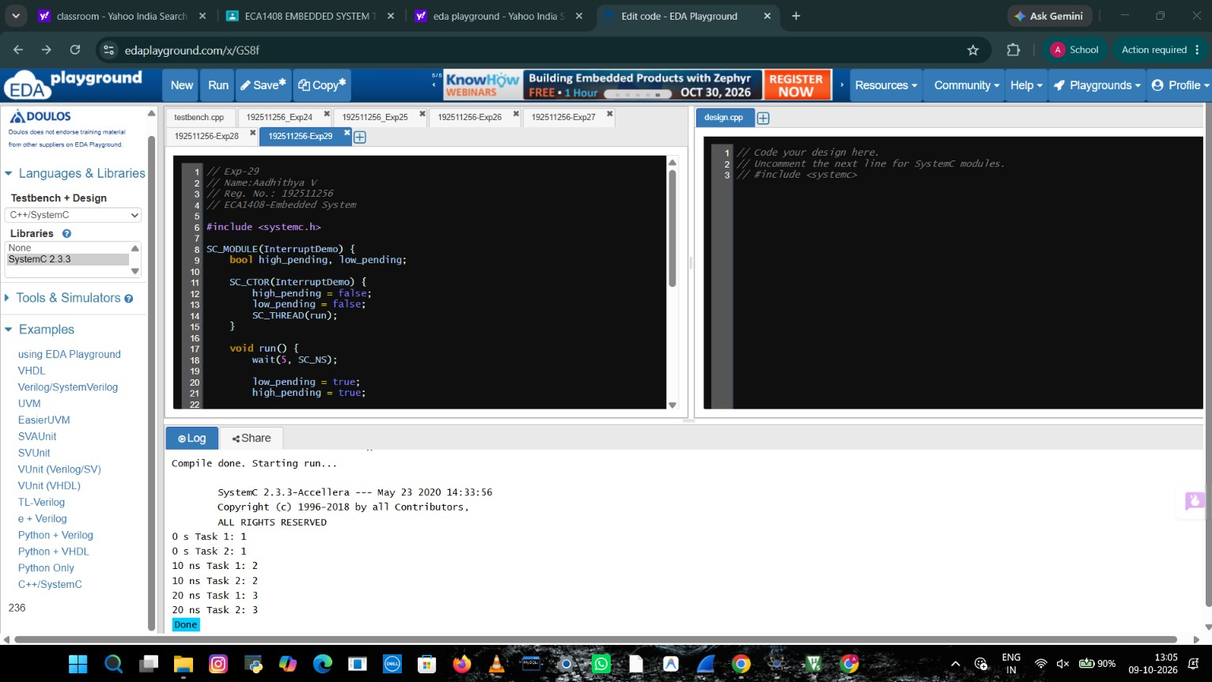

Exp-30:
Code:

#include <systemc.h>

SC_MODULE(RTOSDemo) {
SC_CTOR(RTOSDemo) {
SC_THREAD(scheduler);
}

void scheduler() {
cout << "RTOS Scheduler Started" << endl;

wait(1, SC_NS);
cout << "High Priority Task Executed" << endl;

wait(1, SC_NS);
cout << "Medium Priority Task Executed" << endl;

wait(1, SC_NS);
cout << "Low Priority Task Executed" << endl;

cout << "Scheduling Completed" << endl;
}
};

int sc_main(int argc, char* argv[]) {
RTOSDemo d("d");
sc_start(5, SC_NS);
return 0;
}
Result:
